
G-NOR ELECTRONICS CO.,LTD.

GNL-0603xx  (0603 SMD TYPE)  Ultra Brightness  ABSOLUTE MAXIMUM RATING:(Ta=25℃) |  |  |  | 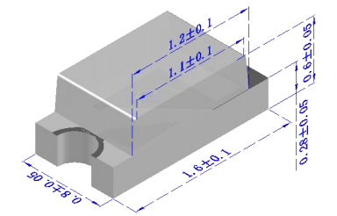  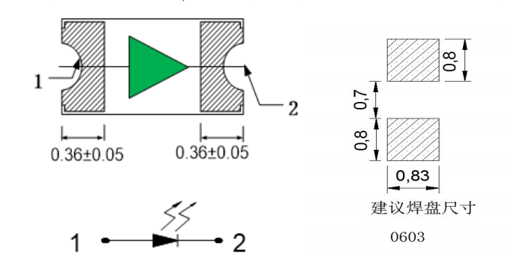  Unit: mm
  Parameter |  |  | Unit
  DC Forward Current | 30 |  | mA
  Reverse Voltage | 5 |  | V
  Reverse Current (Vr-5V) | 10 |  | µA
  Peak Forward Current ,tw ,=1 msec Duty ,=1/20 | 150 |  | mA
  Operation Temperature | -40 | +80 | ℃
  Storage Temperature | -40 | +100 | ℃
  Solder Dip Temperature  (5 seconds,1.6mm from body ) | 300 | ±5 | ℃
Features:
Compatible with automatic placement equipment
Compatible with reflow solder process
Applications:
Automotive and Telecommunication
General use for indicators
Part Number | EMITTED COLOR |  | Lens Color | Peak Wavelength  (nm) | Vf  (v)  Typ. | IV (If=20mA) mcd |  | View Angle  2θ1/2
 |  |  |  |  |  | Min. | Typ. | View Angle  2θ1/2
GNL-0603GC | GaP | Green | Water Clear | 567 | 2.0 | 7 | 12 | 120°
GNL-0603EC | GaP | Orange Red | Water Clear | 635 | 2.0 | 10 | 18 | 120°
GNL-0603YC | GaAsP | Yellow | Water Clear | 588 | 2.0 | 10 | 18 | 120°
GNL-0603SRC | GaAlAs | Red | Water Clear | 660 | 2.0 | 9 | 15 | 120°
GNL-0603LRC | GaAlAs | Super Red | Water Clear | 660 | 1.9 | 30 | 40 | 120°
GNL-0603UGC | AlGaInP | Yellow green | Water Clear | 572 | 2.0 | 22 | 35 | 120°
GNL-0603UYC | AlGaInP | Super Yellow | Water Clear | 587 | 2.1 | 30 | 40 | 120°
GNL-0603UGC | AlGaInP | Yellow Green | Water Clear | 572 | 2.1 | 25 | 35 | 120°
GNL-0603HRC | AlGaInP | Super Red | Water Clear | 640 | 2.1 | 30 | 40 | 120°
GNL-0603UYOC | AlGaInP | Super Amber | Water Clear | 605 | 2.1 | 30 | 40 | 120°
GNL-0603UBC | InGaN | Super Blue | Water Clear | 470 | 3.2 | 40 | 100 | 120°
GNL-0603PGC | InGaN | Super Pure Green | Water Clear | 525 | 3.4 | 200 | 400 | 120°
GNL-0603WC | InGaN | Super White | Water Clear |  | 3.2 | 60 | 100 | 120°
GNL-0603UWC | InGaN | Super White | Water Clear |  | 3.2 | 100 | 150 | 120°

GNL-0603UYC-TL | AlGaInP | Super Yellow | Water Clear |  | 590 | 2.1 | 60 | 150 | 120°
GNL-0603UHRC-TL | AlGaInP | Hyper Red | Water Clear |  | 630 | 2.1 | 100 | 200 | 120°

