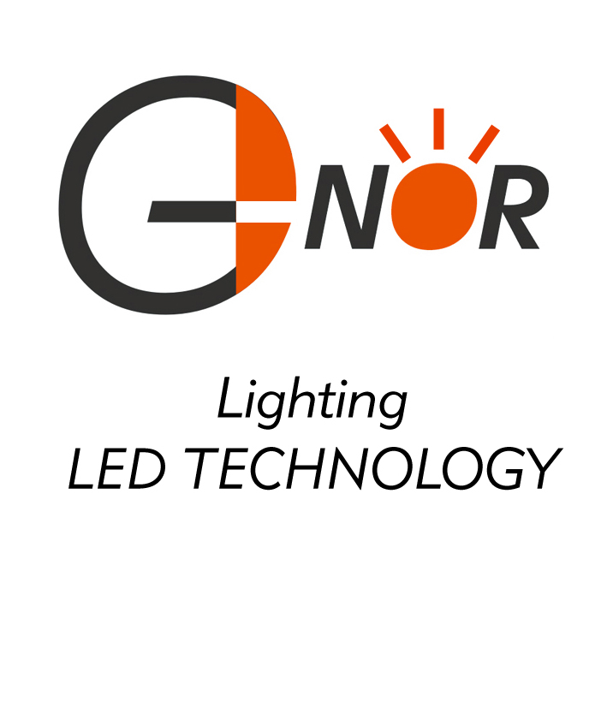
G-NOR ELECTRONICS CO.,LTD.

GNL-1206xx
(1206 SMD TYPE)
Ultra Brightness

ABSOLUTE MAXIMUM RATING:(Ta=25℃)
Parameter |  |  | Unit
DC Forward Current | 30 |  | mA
Reverse Voltage | 5 |  | V
Reverse Current (Vr-5V) | 10 |  | µA
Peak Forward Current ,tw ,=1 msec Duty ,=1/20 | 150 |  | mA
Operation Temperature | -40 | +80 | ℃
Storage Temperature | -40 | +100 | ℃
Solder Dip Temperature  (5 seconds,1.6mm from body ) | 300 | ±5 | ℃

Features:
Compatible with automatic placement equipment
Compatible with reflow solder process

Applications:
Automotive and Telecommunication
General use for indicators
Part Number | EMITTED COLOR |  | Lens Color | Peak Wavelength  (nm) | Vf  (v)  Typ. | IV (If=20mA) mcd |  | View Angle  2θ1/2
 |  |  |  |  |  | Min. | Typ. | View Angle  2θ1/2
GNL-1206GC | GaP | Green | Water Clear | 567 | 2.0 | 7 | 12 | 120°
GNL-1206EC | GaP | Orange Red | Water Clear | 635 | 2.0 | 10 | 18 | 120°
GNL-1206YC | GaAsP | Yellow | Water Clear | 588 | 2.0 | 10 | 18 | 120°
GNL-1206SRC | GaAlAs | Red | Water Clear | 660 | 1.9 | 9 | 15 | 120°
GNL-1206URC | GaAlAs | Super Red | Water Clear | 660 | 1.9 | 65 | 95 | 120°
GNL-1206HRC | AlGaInP | Ultra Red | Water Clear | 640 | 2.1 | 30 | 40 | 120°
GNL-1206UYC | AlGaInP | Super Yellow | Water Clear | 587 | 2.1 | 30 | 40 | 120°
GNL-1206UBC | InGaN | Super Blue | Water Clear | 470 | 3.2 | 40 | 50 | 120°
GNL-1206PGC | InGaN | Super Pure Green | Water Clear | 525 | 3.4 | 70 | 120 | 120°
GNL-1206WC | InGaN | Super White | Water Clear |  | 3.2 | 60 | 100 | 120°

