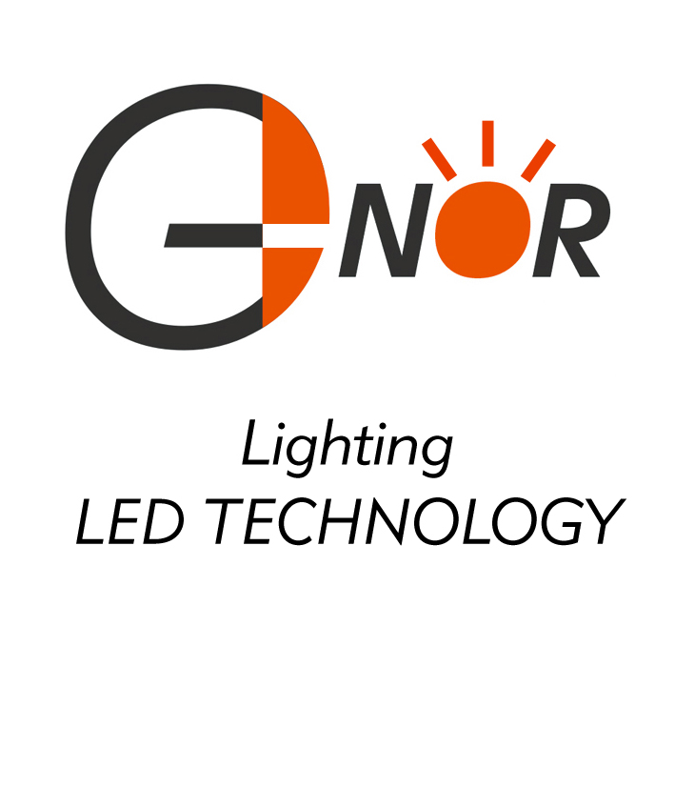
G-NOR ELECTRONICS CO.,LTD.

GNL-5073xx
(Φ5mm ROUND TYPE)
Ultra Brightness

ABSOLUTE MAXIMUM RATING:(Ta=25℃)
Parameter |  |  | Unit
DC Forward Current | 30 |  | mA
Reverse Voltage | 5 |  | V
Reverse Current (Vr-5V) | 10 |  | µA
Peak Forward Current ,tw ,=1 msec Duty ,=1/20 | 150 |  | mA
Operation Temperature | -40 | +80 | ℃
Storage Temperature | -40 | +100 | ℃
Solder Dip  (5 seconds,1.6mm from body ) Temperature | 300 | ±5 | ℃

Feature: Description:
1.Small flange without stand-off 1.The shape of this series is round
2.Long life-solid state reliability 2.General application is for indication,illumination,etc.
3.Long lead length(25.4mm) 3.These LED lamps are available with a choice of defferent
4.Versatile mounting on P.C. board or panel colors,light intensities,epoxy colors,etc.

Part Number | EMITTED COLOR |  | Lens Color | Peak Wavelength  (nm) | Vf  (v)  Typ. | IV (If=20mA) mcd |  | View Angle  2θ1/2
 |  |  |  |  |  | Min. | Typ. | View Angle  2θ1/2
GNL-5073URC | GaAlAs | Super Red | Water Clear | 660 | 1.9 | 80 | 150 | 120°
GNL-5073UEC | AlGaInP | Super Red | Water Clear | 625 | 2.0 | 80 | 150 | 120°
GNL-5073HRC | AlGaInP | Super Red | Water Clear | 640 | 2.0 | 70 | 120 | 120°
GNL-5073UYC | AlGaInP | Super Yellow | Water Clear | 590 | 2.0 | 80 | 150 | 120°
GNL-5073UBC | InGaN | Super Blue | Water Clear | 470 | 3.5 | 90 | 150 | 120°
GNL-5073PGC | InGaN | Pure Green | Water Clear | 525 | 3.5 | 300 | 400 | 120°
GNL-5073BGC | InGaN | Super Cyan | Water Clear | 505 | 3.5 | 200 | 300 | 120°
GNL-5073UGC | AlGaInP | Yellow Green | Water Clear | 572 | 2.0 | 60 | 100 | 120°
GNL-5073UEC-TL | AlGaInP | Ultra Super Red | Water Clear | 625 | 2.0 | 150 | 250 | 120°
GNL-5073UYC-TL | AlGaInP | Ultra Super Yellow | Water Clear | 590 | 2.0 | 150 | 250 | 120°
GNL-5073UBC-TL | InGaN | Ultra Super Blue | Water Clear | 470 | 3.5 | 150 | 250 | 120°
GNL-5073PGC-TL | InGaN | Ultra Super Green | Water Clear | 525 | 3.5 | 400 | 500 | 120°
GNL-5073UWC | InGaN | Ultra Super White | Water Clear | 5500K-7000K | 3.5 | 700 | 800 | 120°
GNL-5073UWC-Y | InGaN | Ultra Warm White | Water Clear | 2700K-3500K | 3.5 | 500 | 600 | 120°

