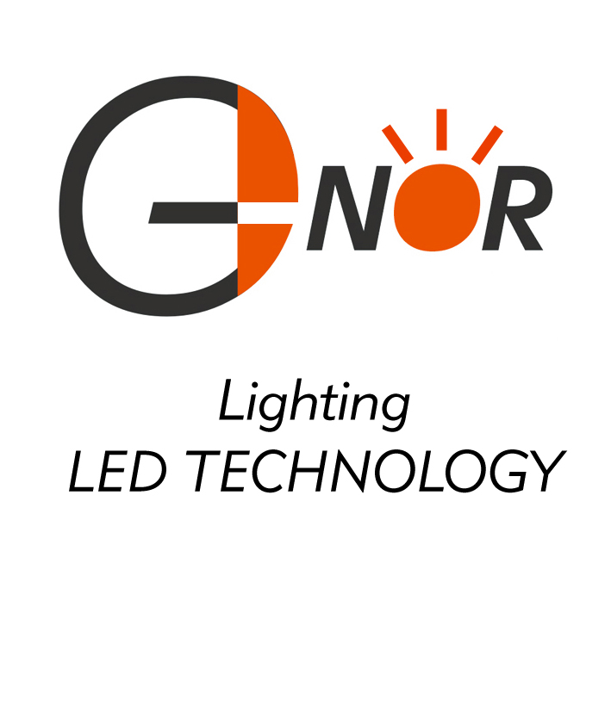
G-NOR ELECTRONICS CO.,LTD.

GNL-5033xx
(Φ5mm Flat Top TYPE)
Ultra Brightness

ABSOLUTE MAXIMUM RATING:(Ta=25℃)
Parameter |  |  | Unit
DC Forward Current | 30 |  | mA
Reverse Voltage | 5 |  | V
Reverse Current (Vr-5V) | 10 |  | µA
Peak Forward Current ,tw ,=1 msec Duty ,=1/20 | 150 |  | mA
Operation Temperature | -40 | +80 | ℃
Storage Temperature | -40 | +100 | ℃
Solder Dip  (5 seconds,1.6mm from body ) Temperature | 300 | ±5 | ℃

Feature:
1.Small flange without stand-off
2.Long life-solid state reliability
3.Long lead length(25.4mm)
4.Versatile mounting on P.C. board or panel

Description:
1.The shape of this series is round
2.General application is for indication,illumination,etc.
3.These LED lamps are available with a choice of defferent
colors,light intensities,epoxy colors,etc.
Part Number | EMITTED COLOR |  | Lens Color | Peak Wavelength  (nm) | Vf  (v)  Typ. | IV (If=20mA) mcd |  | View Angle  2θ1/2
 |  |  |  |  |  | Min. | Typ. | View Angle  2θ1/2
GNL-5033URC | GaAlAs | Super Red | Water Clear | 660 | 1.9 | 110 | 120 | 90°
GNL-5033UEC | AlGaInP | Super Orange | Water Clear | 625 | 2.0 | 120 | 130 | 90°
GNL-5033HRC | AlGaInP | Super Orange | Water Clear | 640 | 2.0 | 60 | 90 | 90°
GNL-5033UGC | AlGaInP | Yellow Green | Water Clear | 572 | 2.0 | 50 | 70 | 90°
GNL-5033UYC | AlGaInP | Super Yellow | Water Clear | 588 | 2.0 | 120 | 130 | 90°
GNL-5033UBC | InGaN | Ultra Super Blue | Water Clear | 470 | 3.5 | 200 | 250 | 90°
GNL-5033PGC | InGaN | Super Pure Green | Water Clear | 525 | 3.5 | 550 | 600 | 90°
GNL-5033UEC-TL | AlGaInP | Super Orange | Water Clear | 625 | 2.0 | 300 | 320 | 90°
GNL-5033UYC-TL | AlGaInP | Super Yellow | Water Clear | 588 | 2.0 | 300 | 320 | 90°
GNL-5033UWC | InGaN | Super white | Water clear | 5500K-7000K | 3.5 | 300 | 500 | 90°

