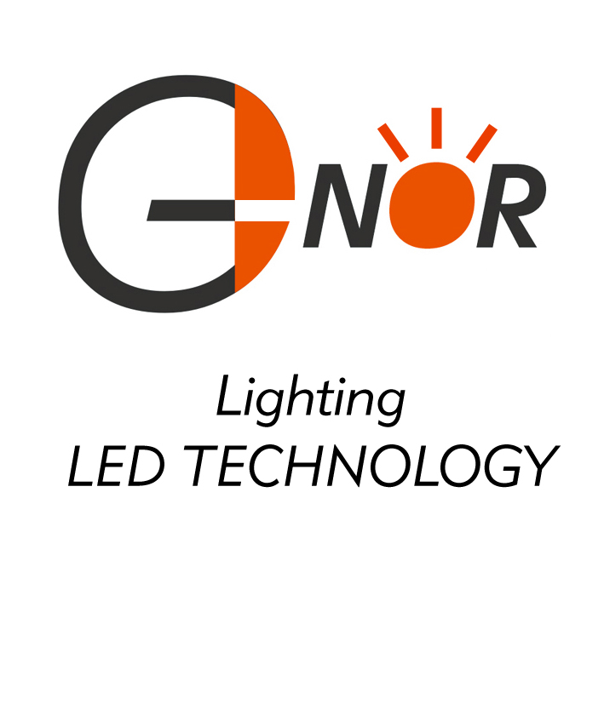
G-NOR ELECTRONICS CO.,LTD.

GNL-3014xx
(Φ3mm ROUND TYPE)
Ultra Brightness

ABSOLUTE MAXIMUM RATING:(Ta=25℃)
Parameter |  |  | Unit
DC Forward Current | 30 |  | mA
Reverse Voltage | 5 |  | V
Reverse Current (Vr-5V) | 10 |  | µA
Peak Forward Current ,tw ,=1 msec Duty ,=1/20 | 150 |  | mA
Operation Temperature | -40 | +80 | ℃
Storage Temperature | -40 | +100 | ℃
Solder Dip  (5 seconds,1.6mm from body ) Temperature | 300 | ±5 | ℃

Part Number | EMITTED COLOR |  | Lens Color | Peak Wavelength  (nm) | Vf  (v)  Typ. | IV (If=20mA) mcd |  | View  Angle  2θ1/2
 |  |  |  |  |  | Min. | Typ. | View  Angle  2θ1/2
GNL-3014SRD | GaAlAs | Super Red | Red Diffused | 660 | 1.9 | 70 | 100 | 60°
GNL-3014SRT | GaAlAs | Super Red | Red Transparent | 660 | 1.9 | 150 | 200 | 25°
GNL-3014SRC | GaAlAs | Super Red | Water Clear | 660 | 1.9 | 150 | 200 | 25°
GNL-3014LRC | GaAlAs | Super Red | Water Clear | 660 | 1.9 | 200 | 300 | 25°
GNL-3014URC | GaAlAs | Super Red | Water Clear | 660 | 1.9 | 500 | 600 | 25°
GNL-3014UEC | AlGaInP | Super Orange | Water Clear | 625 | 2.0 | 1000 | 1500 | 25°
GNL-3014HRC | AlGaInP | Super Orange | Water Clear | 640 | 2.0 | 500 | 800 | 25°
GNL-3014HRT | AlGaInP | Super Orange | Red Transparent | 640 | 2.0 | 500 | 800 | 25°
GNL-3014HRD | AlGaInP | Super Orange | Red Diffused | 640 | 2.0 | 150 | 300 | 60°
GNL-3014UGC | AlGaInP | Yellow Green | Water Clear | 572 | 2.0 | 350 | 500 | 25°
GNL-3014GC | GaP | Green | Water Clear | 565 | 2.0 | 30 | 40 | 25°
GNL-3014YC | GaAsP | Yellow | Water Clear | 588 | 2.0 | 30 | 40 | 25°
GNL-3014UYC | AlGaInP | Super Yellow | Water Clear | 589 | 2.0 | 800 | 1000 | 25°
GNL-3014BC | InGaN | Super Blue | Water Clear | 470 | 3.5 | 1000 | 1500 | 25°
GNL-3014UBC | InGaN | Ultra Super Blue | Water Clear | 470 | 3.5 | 1200 | 2000 | 25°
GNL-3014BGC | InGaN | Super Bluish Green | Water Clear | 505 | 3.5 | 2500 | 4000 | 25°
GNL-3014PGC | InGaN | Super Pure Green | Water Clear | 525 | 3.5 | 2500 | 4000 | 25°
GNL-3014UWC | InGaN | Ultra Super White | Water Clear | 5500K-7000K | 3.5 | 2000 | 3000 | 25°
GNL-3014VC | InGaN | Super Violet | Water Clear | 400 | 3.5 | 150 | 300 | 25°

